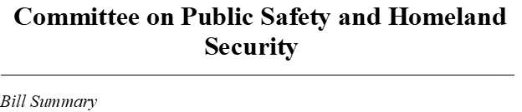
Bill Number: H2690
Name: An Act relative to violation of regulation regarding hot work process

Sponsor(s): Representative Ryan Daniel

Hearing Date: TBD

Prior History:

Summary:
This bill calls for fire departments to collab with license department and code enforcement officers to collect data on induvial who violate rules and regulation for hot works.

