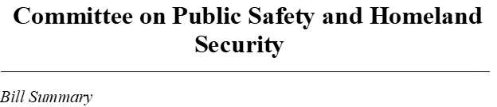
Bill Number: H2737
Name: An Act relative to the emergency response in an active shooter or hostile situation

Sponsor(s): Representative Xiahros Steven

Hearing Date: TBD

Prior History: Favorable

Summary:
This bill will have the Commonwealth adopt the NFPA 3000 protocols for public safety and first responders in response to Active Shooter/ Hostile Event Response (ASHER)

