

April 14, 2025

The Honorable Thomas M. Stanley, House Chair
Joint Committee on Aging and Independence
Boston, MA 02133

The Honorable Patricia D. Jehlen, Senate Chair
Joint Committee on Aging and Independence
Boston, MA 02133

Dear Chairs Stanley, Jehlen, and members of the Joint Committee on Aging and Independence:

I write today in support of a bill I filed with Rep. Donaghue, H.765 An Act relative to councils on aging. Massachusetts Councils on Aging was codified in statute in 1979, bringing together senior centers from around the Commonwealth. They have served as lifelines for thousands of older adults during the COVID-19 pandemic and have experienced tremendous growth in the last decade. The programs and services they implement meet the needs of all older adults.

Since the state statute was enacted in 1979, the Councils have changed to meet the needs of the expanding population served and remains an integral part of municipalities. This bill would update an outdated statute that lacks clarity to reflect the current scope of the Councils. Consistency amongst the Councils is necessary by acknowledging the status of the Councils as either supervisory or advisory, and clarifying the structure of oversight and hiring of staff.

I respectfully urge the Committee to favorably report out H.765 to secure critical services for our elderly community. I look forward to working with the Committee on this bill.

Thank you for your consideration,
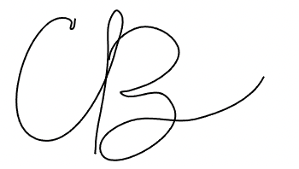
State Representative Christine P. Barber
34th Middlesex District

