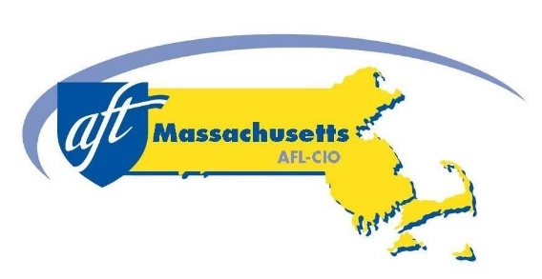

Facial Recognition Special Legislative Commission Meeting, July 30, 2021

**Testimony in Support of Keeping Facial Recognition Out of Public Schools**

As the Facial Recognition Special Legislative Commission (FRSLC) continues its work examining the issue of facial recognition (FR) in Massachusetts and considering recommendations for legislation, the American Federation of Teachers Massachusetts (AFT MA) urges the FRSLC to include in its recommendations a ban on the use of facial recognition (FR) in the Commonwealth’s public schools.

AFT MA and its largest local affiliate, the Boston Teachers Union, have both come out in favor of a ban on the use of FR in public schools.

A [2020 study from the University of Michigan’s Science, Technology and Public Policy Program](http://stpp.fordschool.umich.edu/sites/stpp.fordschool.umich.edu/files/file-assets/cameras_in_the_classroom_executive_summary.pdf) called for the outright ban of facial recognition in schools after finding “that FR will likely have five types of implications: exacerbating racism, normalizing surveillance and eroding privacy, narrowing the definition of the “acceptable” student, commodifying data, and institutionalizing inaccuracy.” These outcomes are unacceptable and warrant a ban on the use of facial recognition in schools.

After examining 189 algorithms from 99 developers, a majority of the industry, a [2019 study from the U.S. Department of Commerce's National Institute of Standards and Technology (NIST)](https://www.nist.gov/news-events/news/2019/12/nist-study-evaluates-effects-race-age-sex-face-recognition-software) found higher rates of false positives for Asian and African American faces compared to images of Caucasian faces.

The New York Times Op Ed writer Charlie Warzel wrote on June 27, 2019, that the largest maker of police body cameras, Axon, banned the use of FR software on its devices. “Face recognition technology is not currently reliable enough to ethically justify its use,” the company’s independent ethics board concluded.

In an interview published June 9, 2020 in the NYT Timnit Gebru, a leader of Google’s ethical artificial intelligence team, explained why she believes that facial recognition is too dangerous to be used right now for law enforcement purposes. “I collaborated with [Joy Buolamwini](https://www.ajlunited.org/about) at the M.I.T. Media Lab, who led an [analysis](http://gendershades.org/) that found [very high disparities in error rates](https://www.nytimes.com/2018/06/21/opinion/facial-analysis-technology-bias.html) [in facial identification systems], especially between lighter-skinned men and darker-skinned women.”

Local governments in Massachusetts, including Boston, Springfield, Somerville and Brookline have banned use of FR in their municipalities. A state ban on FR in schools should be instituted as soon as possible. New York State passed a ban on FR last year and Maine passed a comprehensive ban just last month. San Francisco banned it in 2019. Now it’s the Commonwealth’s turn to ban this unreliable and discriminatory technology.

AFT MA urges the Facial Recognition Special Legislative Commission to declare its support for H. 135/S.47, An Act to regulate facial surveillance.