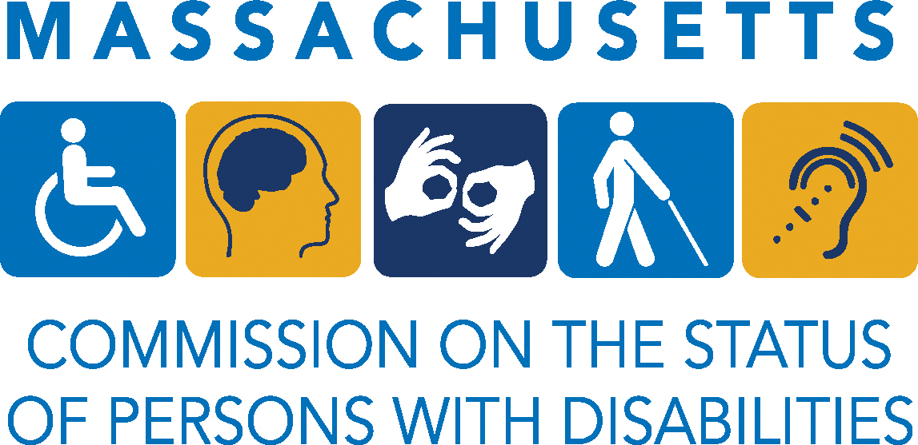

FOR IMMEDIATE RELASE
May 16, 2025

CONTACT
Imene Bouziane Saidi, Executive Director
Massachusetts Commission on the Status of Persons with Disabilities
Imene.BouzianeSaidi@mass.gov

MASSACHUSETTS PERMANENT COMMISSION ON THE STATUS OF PERSONS WITH DISABILITIES TO HOST INFORMATIONAL HEARING ON DISABILITY HEALTH EQUITY

BOSTON, MA – On Monday, May 19, 2025, the MA Permanent Commission on the Status of Persons with Disabilities will host an informational hybrid hearing at the Massachusetts State House focused on advancing health equity for people with disabilities across the Commonwealth.
WHO: | Dr. Linda Long Bellil, UMass Chan Medical School  Dr. Craig Andrade, Health Equity Compact  Keith Jones, Disability Rights Advocate  Nassira Nicola, MA Department of Public Health  Erica Guimarães, MassHealth  Heather Watkins, Disability Rights Advocate  John Madondo, United HealthCare  Dr. Joseph Giacino, Spaulding Rehab, Mass General Hospital, Harvard Medical School  Nicole Godaire, Brain Injury Association of MA  Maura Sullivan, The Arc of MA  Members of the Permanent Commission on the Status of Persons with Disabilities  Members of the Disability Community  Healthcare professionals and public health experts  Community-based organizations
WHAT: | This hearing serves as an opportunity for invited subject matter experts to introduce themselves to the Commission and identify significant priorities and challenges relevant to health equity for people with disabilities. The discussion will focus on the systemic barriers, ongoing initiatives, and opportunities for collaboration between state agencies, healthcare leaders, and disability advocates. This hearing is not intended to address specific legislation or pending bills. Testimony will be limited to invited organizations, though members of the public are welcome to attend and observe.
WHEN: | Monday, May 19 at 10:30 am
WHERE: | Room 428, Massachusetts State House: 24 Beacon St, Boston, MA 02133 and on zoom: registration: https://docs.google.com/forms/d/e/1FAIpQLSfGQX3RmgysLODSILM2X0i43CC54Qlw2zKC-CZwZaN9iyyDIg/viewform?usp=header
WEBSITE: | https://www.mass.gov/news/informational-hearing-advancing-health-equity-for-people-with-disabilities

###

